**Sample Output and Current Performance Report**

1. **Sample Output**

The output of the emotion detection will be classified into 6 class (happy, sad, surprised, disgusting, angry and sad). The data will be processed using NN / KNN to determine which class data belongs to. Each of class will give the confidence value within range 0 to 1 which means 0% to 100% in percent scale (multiplied by 100).

* Happy Detection Ranking.

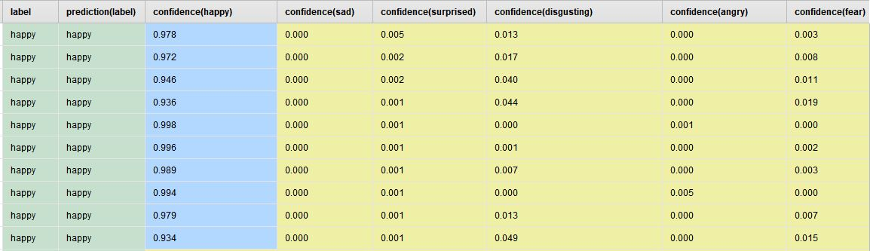

In the first row of happy data class, happy detected as happy with the value of confidence as mentioned below:

* Ranked Data

1. Happy : 0.97 (Rank 1)
2. Sad : 0.00 (Rank 5)
3. Surprised : 0.005 (Rank 3)
4. Disgusting : 0.013 (Rank 2)
5. Angry : 0.00 (Rank 6)
6. Fear : 0.003 (Rank 4)

* Sad Detection Ranking.

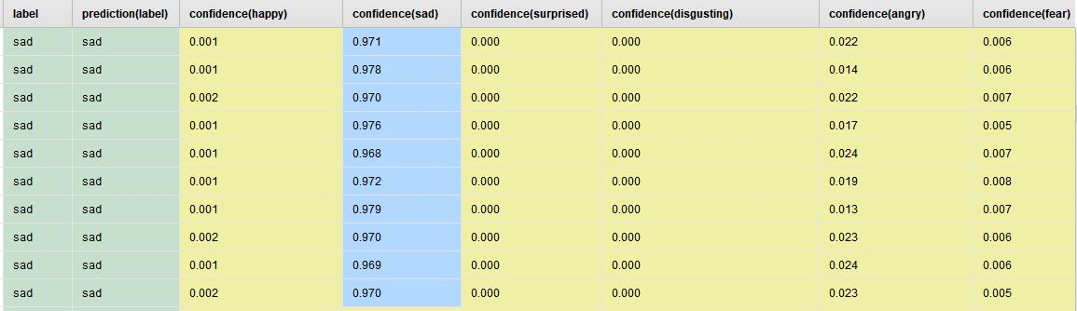

In the first row of sad data class, sad detected as sad with the value of confidence as mentioned below:

* Ranked Data

1. Happy : 0.001 (Rank 4)
2. Sad : 0.971 (Rank 1)
3. Surprised : 0.00 (Rank 5)
4. Disgusting : 0.00 (Rank 6)
5. Angry : 0.022 (Rank 2)
6. Fear : 0.006 (Rank 3)

* Surprised Detection Ranking.

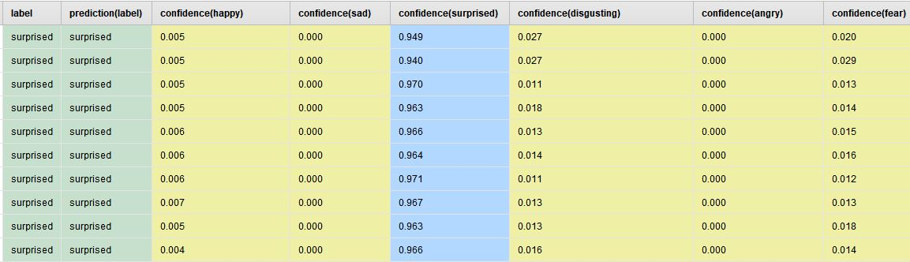

In the first row of surprised data class, surprised detected as surprised with the value of confidence as mentioned below:

* Ranked Data

1. Happy : 0.005 (Rank 4)
2. Sad : 0.00 (Rank 5)
3. Surprised : 0.949 (Rank 1)
4. Disgusting : 0.027 (Rank 2)
5. Angry : 0.00 (Rank 6)
6. Fear : 0.02 (Rank 3)

* Disgusting Detection Ranking.

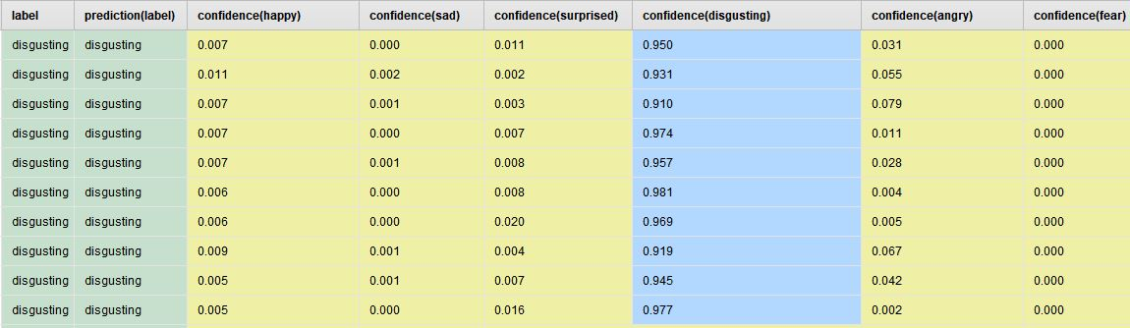

In the first row of disgusting data class, disgusting detected as disgusting with the value of confidence as mentioned below:

* Ranked Data

1. Happy : 0.007 (Rank 4)
2. Sad : 0.00 (Rank 5)
3. Surprised : 0.011 (Rank 3)
4. Disgusting : 0.95 (Rank 1)
5. Angry : 0.031 (Rank 2)
6. Fear : 0.00 (Rank 6)

* Angry Detection Ranking.

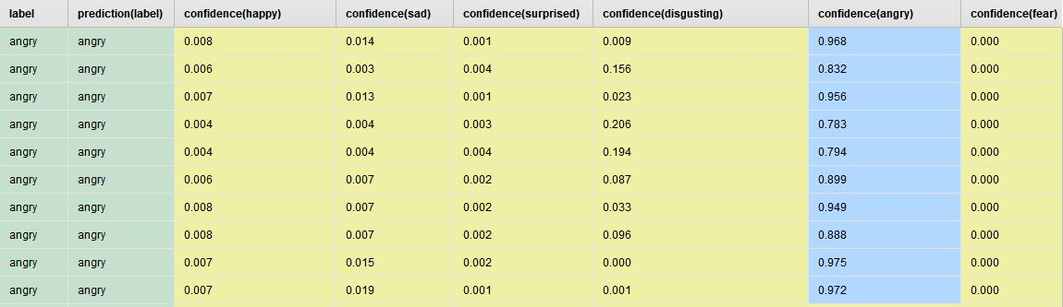

In the first row of angry data class, angry detected as angry with the value of confidence as mentioned below:

* Ranked Data

1. Happy : 0.008 (Rank 4)
2. Sad : 0.014 (Rank 2)
3. Surprised : 0.001 (Rank 5)
4. Disgusting : 0.009 (Rank 3)
5. Angry : 0.968 (Rank 1)
6. Fear : 0.00 (Rank 6)

* Fear Detection Ranking.

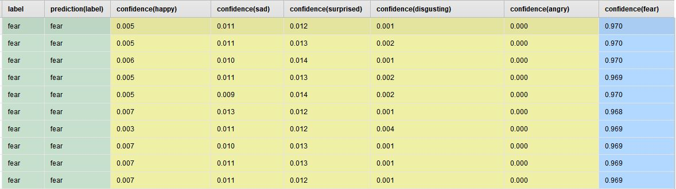

In the first row of fear data class, fear detected as fear with the value of confidence as mentioned below:

* Ranked Data

1. Happy : 0.005 (Rank 4)
2. Sad : 0.011 (Rank 3)
3. Surprised : 0.012 (Rank 2)
4. Disgusting : 0.001 (Rank 5)
5. Angry : 0.00 (Rank 6)
6. Fear : 0.970 (Rank 1)
7. **Current Performance Report**

We have obtained data from 5 people with 10 experiments for each emotion, the total of data is 300 data. We use Rapid Miner to check our current performance using cross validation 10 folds. We use NN and KNN here to compare the performance. The result of the performance can be seen as below.

* Neural Network.

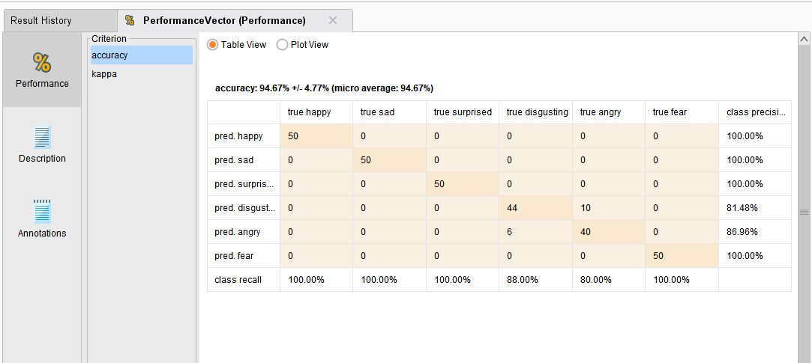

We use NN with 200 training cycle, 0.01 learning rate and 0.9 momentum.

When using NN, we get 94.67% in accuracy total with 4.77% in deviation. Happy, sad, surprised and fear, all of their data have correctly classified with 100% accuracy and precision. 6 disgusting data wrongly classified and 44 correctly classified with accuracy 88% and precision 81.48. 10 angry data wrongly classified and 40 correctly classified with accuracy 80% and precision 86.96.

* K-NN

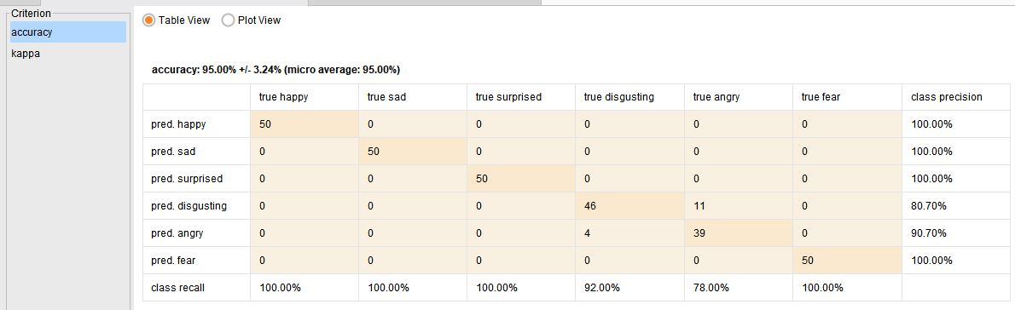

We use K-NN with K : 5 using Euclidean Distance.

When using K-NN, we get 95% in accuracy total with 3.24% in deviation. Happy, sad, surprised and fear, all of their data have correctly classified with 100% accuracy and precision. 4 disgusting data wrongly classified and 46 correctly classified with accuracy 92% and precision 80.70. 11 angry data wrongly classified and 39 correctly classified with accuracy 78% and precision 90.7%.